Database Design and API Documentation

- Database Design

This project has 2 tables, namely concert and reservation.

- Concert Table

SQL Querry for create table:
Open create-concert-table.txt
SQL Query to populate the concert table:
Open populate-concert-table.txt

contents of the concert table:
id (Primari Key)
name (name of the concert)
artist (concert performers)
date (concert dates)
total_tickets (total number of tickets)
available_tickets (number of tickets still available)
status (concert status)
venue (concert venue)
start_sell_date (opening time for concert ticket purchase)
end_sell_date (closing time for concert ticket purchase)

- Reservation Table

SQL Querry for create table:
Open create-reservation-table.txt
contents of the reservation table:
id (Primari Key)
concert_id (reference from concert table field id)
user (ticket buyer's name)
number_of_tickets (number of tickets booked)
booking_time (time when booking)
status (ticket purchase status)
payment_method (ticket payment method)
payment_time (ticket payment time)

- API Documentation

api documentation can be found in the edts.postman_collection.json file

- search available concerts

Example url and request:
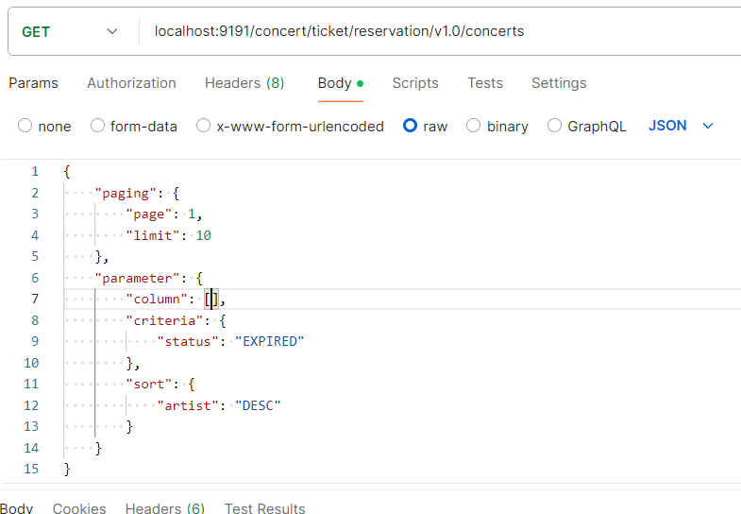

For the convenience of the Frontend in creating a flexible interface, the following request is made.
- first there is paging in which there is a page and there is a limit.
- page is used by the user to choose how many pages to open
- limit is used by the user to determine how much data is in 1 page.
- secondly there are parameters in which there are columns, criteria and sort
- column is used by the user to display what fields will be displayed.
- criteria is used by the user to determine or filter what fields and values to look for
- sort is used by the user to sort both ascending (asc) and descending (desc) on a field

Example response:
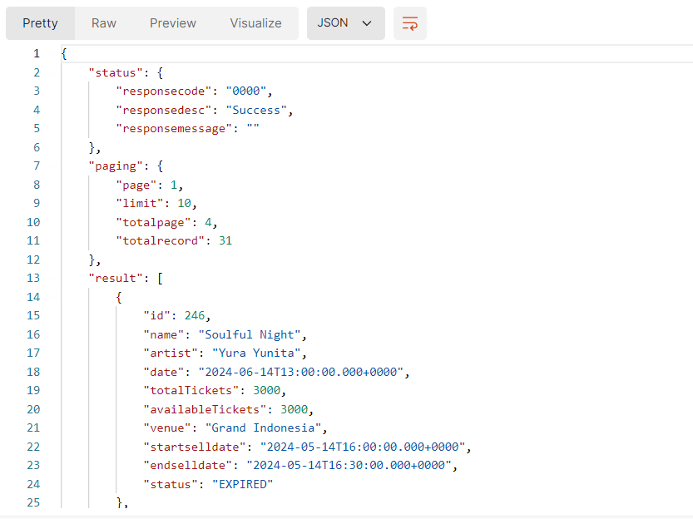

for response results can be divided into 3 parts namely status, paging and result
- status contains responsecode (specific business code), responsedesc (business description) and responsemessage (full explanation).
- paging contains page (the destination page), limit (the amount of data in one page), totalpage (the number of search result pages), totalrecord (the amount of search result data)
- result contains array data displayed

- Reservation Ticket

example url and request:

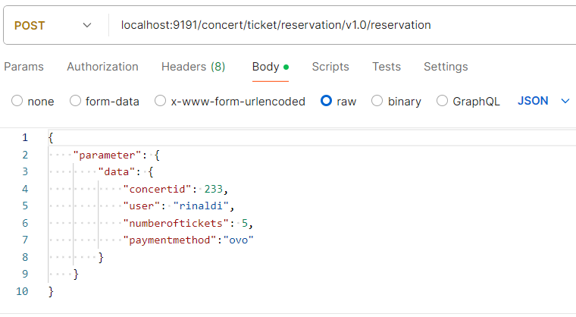

for filling json requests there are 3 layers. the first layer contains parameters in the parameters then the data layer and in the data there is a layer of fields from the reservation table.

Example response:

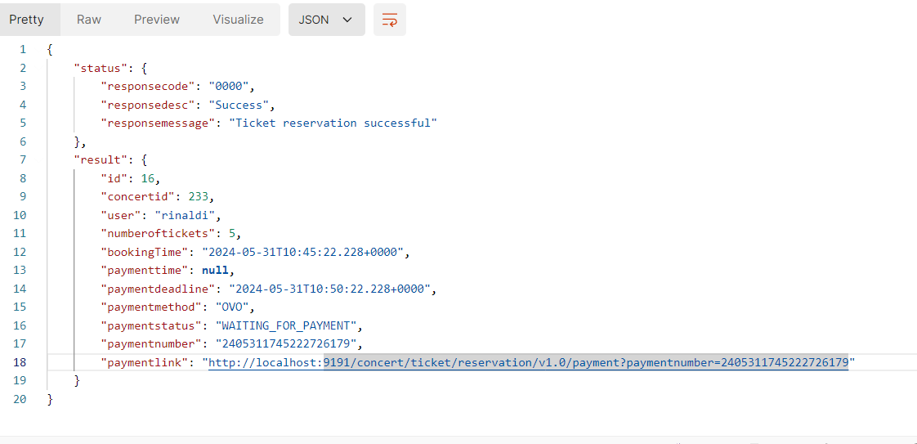
for response results can be divided into 2 parts namely status and result
- status contains responsecode (specific business code), responsedesc (business description) and responsemessage (full explanation).
- result contains array data displayed
- Ticket Payment

Example url and request:
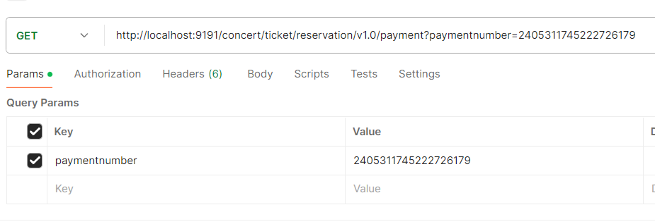

The request url for ticket payment can be obtained from the response result during reservation where the field key is paymentlink.

Example Response :
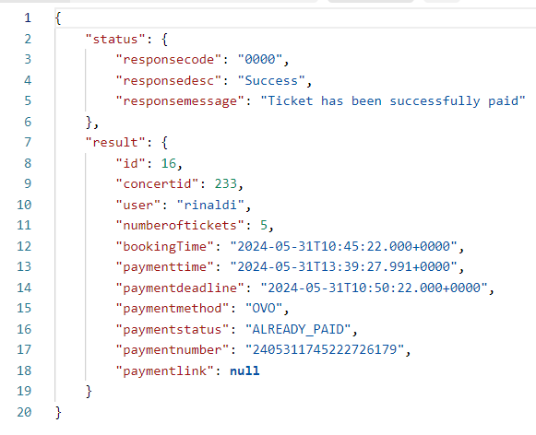

for response results can be divided into 2 parts namely status and result
- status contains responsecode (specific business code), responsedesc (business description) and responsemessage (full explanation).
- result contains array data displayed

